**ERIS ISSUE RECREATION EPM Doesn’t Display Full Length Output for Bytes32**

Summary: We make a contract that returns a bytes32 object that it takes as input. Incidentally, the epm can only display up to 31 characters as output. After 31 characters, the epm will not display any output values. We believe that perhaps there was a confusion between bytes and characters in output. In all cases we made wait equal to true in the epm.

Output:

When we have an object with 31 characters in our epm, such as 1111111111111111111111111111111, this is the output (note it has 31 characters and it is also not equal to the input):

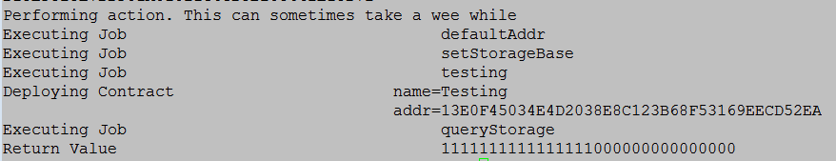

When we have an object with more than or equal to 32 characters in our epm, such as: 1111111111111111111111111111111, there is no output:

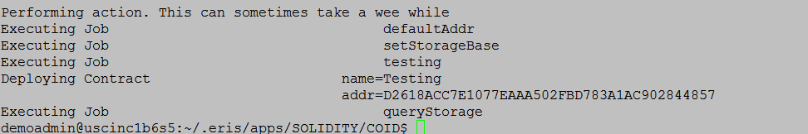

Issue Recreation

**Contract**

contract Testing {

function testing1(bytes32 input) returns (bytes32 hi)

{

hi = input;

}

}

**EPM That displays output (31 characters)**

demoadmin@uscinc1b6s5:~/.eris/apps/SOLIDITY/COID$ cat epm.yaml

jobs:

- name: setStorageBase

job:

set:

val: 1111111111111111111111111111111

- name: testing

job:

deploy:

contract: Testing.sol

wait: true

- name: queryStorage

job:

call:

destination: $testing

data: testing1 $setStorageBase

wait: true

**EPM That has no output (More than 31 characters)**

jobs:

- name: setStorageBase

job:

set:

val: 11111111111111111111111111111111

- name: testing

job:

deploy:

contract: Testing.sol

wait: true

- name: queryStorage

job:

call:

destination: $testing

data: testing1 $setStorageBase

wait: true